Element Converter

* **Introduction:**
* This project is used to make it simple to understand how to convert an element into a set, list, or tuple.
* For backend : Python
* For Frontend: HTML, CSS, JavaScript
* **Problem Domain:**
* As this 3 concepts (List, Set and Tuple) are very similar and create some confusion to understand.
* The main confusion is created because 3 of them have different rules a.
* **Solution Domain:**
* To solve this problems I visualized this 3 concepts that makes it easy for user to understand.
* **Requirements:**
* **Software** : Visual Code, for Browser in chrome.
* **Hardware**:
  + - Processor: Any modern processor.
    - RAM: At least 2GB.
    - Storage: 100MB for project files.
    - Display: Resolution of 1366x768.
* **Data Structure Used:**
* SET is an unordered collection of unique elements.
* TUPLE is an ordered, immutable collection.
* LIST is an ordered, mutable collection of elements.
* **Methodology:**

STEP 1:- Firstly open this Page.

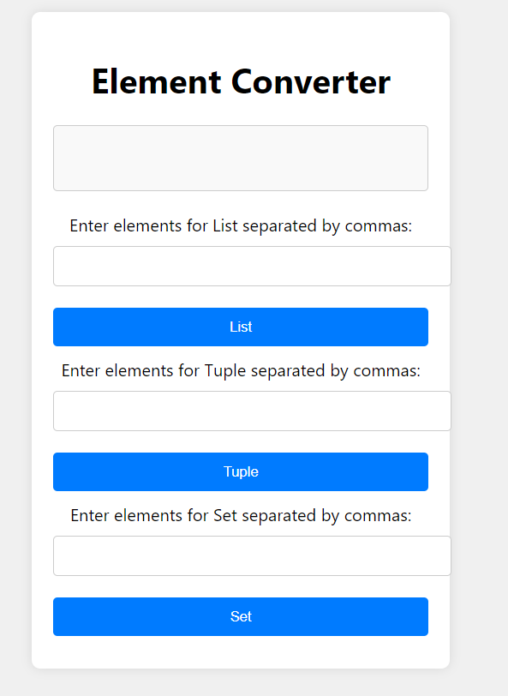

STEP 2:- Insert element (True,10,20,1,10,0) in LIST.

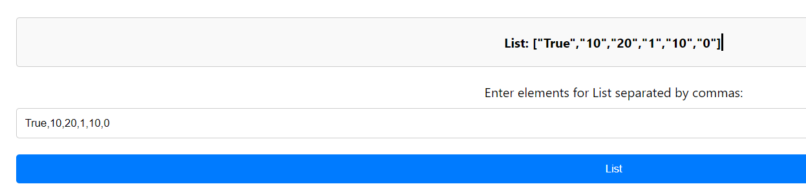

STEP 3:- Insert element (True,10,20,1,10,0) in TUPLE.

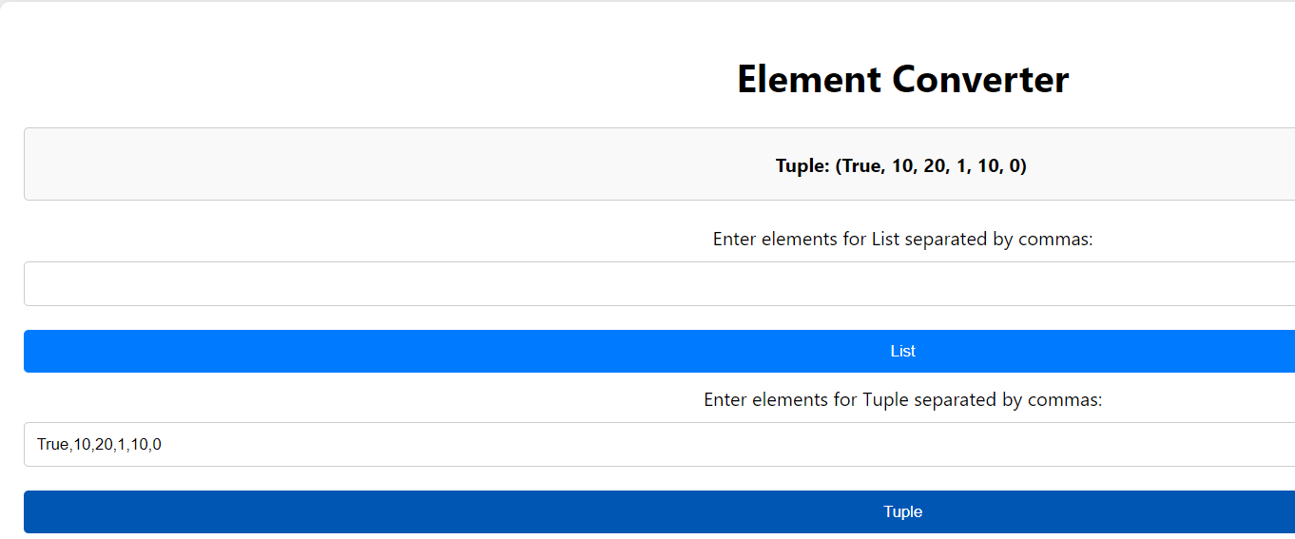

STEP 4:- Insert element (True,10,20,1,10,0) in SET.

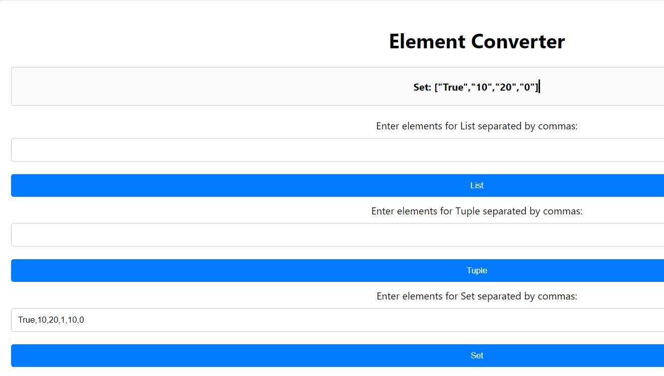

* **Summary:**
  + This 3 concepts (LIST,SET and TUPLE) are very similar and create some confusion to understand.
  + A Set is an unordered collection of unique elements and a Tuple is an ordered immutable collection and a List is an ordered, mutable collection of elements and so the output will be according to this rules.
  + So, in my project using Visualization user can easily understand.
  + In this website firstly Enter elements then click LIST or SET or TUPLE button in which you want to get output.
* **Conclusion:**
* Using this project user can easily understand this DSA concepts.